Meeting with Heather and Sam to discuss Social Justice Training Program. February 6, 2013, 10am-11am
Heather and Sam have been working together to plan the Social Justice Training Program (SJTP) for awhile now, but have invited me to join as part of my placement. This meeting was intended to catch me up about what the workshops would be about and to discuss the schedule of events for Saturday’s workshop, which was intended to be a general introduction to privilege.
Looking ahead:
The three workshops will all be about privilege in some way. We will start by thinking about privilege generally and the privileges we have as individuals, and then build on that. Sam said, the first workshop is kind of like “Yo, got privilege?” and the next will be “power/privilege”. We talk about trying to include both students and faculty in the second in third workshop, hoping they can lead 30-45 minute workshops. We write a list of people to contact. We are trying to think of people who commonly do this type of work, as well as get some new faces in the mix. The next two workshops will also be about privilege, but build off of our learning in the earlier workshop(s).
Schedule for Saturday:
Introduction and Icebreaker: 18 students will attend. Do we expect people to learn names? Let’s use name tags, but say we hope to learn each other’s names. What social justice oriented ice breaker can we do? Say a word the represents what they hope to get out of the workshop? Maybe too easy. Say their favorite quote or lyric that is related to social justice? Maybe too hard. We decide to allow for a range: say your name and either a quote, phrase, lyric, metaphor, or word that has to do with social justice.
Guidelines for “Safe Space”: Have some ready to go so we don’t spend too much time on this, but allow for comments or edits.
Revised Privileged Walk, Privilege Bouquet: Hang signs around the room with different statements in regard to privilege. Next to each sign will be small slips of paper with the statement on it. Take a slip of paper for each slip that applies to you (example sign: I have regular access to internet). After going around the room and looking at all the signs and collecting slips of paper, we’ll discuss the activity. We don’t need to count our slips or make anyone feel uncomfortable if they have a lot of slips. After the activity break up into small groups and discuss the activity and topics of privilege. Maybe have a silent writing period if people don’t seem quite ready to jump into conversation.
Conclusion: Wrap up and assign “homework”. Homework includes bringing a friend to the next workshop and/or making an effort to disrupt or confront situations where privilege is being misused, people are unaware of privilege, etc.
Meeting with Sam to discuss the goals and objectives of my placement. February 8, 2013, 12:30-1:15
Sam talks about how there was a meeting that morning where they had to present to the administration and board of trustees their long term goals for the office (of multicultural affairs) in general. She told me a little bit of what was said, because she thought it was useful information for someone who wants to learn more about what it’s like to work in such an office. She wants to shift programs from isolation to campus wide over time. She thinks that safe spaces for certain groups, such as people of color, first generation students, students who identify as lgbtq, etc., are extremely important, but it’s also important to engage with the community at large. She also mentioned in general it’s good to look into best practices of other small liberal arts colleges and seven sisters.
At times she would give real life examples to clarify things she was saying, or I would share a story of something that reminded me of what she was telling me. One thing that she said that caught my attention was that when the issue of comfortability of allies becomes more important than safety of targeted group this is a bad practice.

After talking more generally about the office, she brought up a few projects I could be involved in:
- Diversity Council- this group hasn’t met in a long time (months? Years?) and they want to strategically reorganize it. There are logistical pieces I could be involved in, and this work has to do with institutionalizing diversity work.
- Spectra web resources: Bryn Mawr has made a statement on their website about gender identity and expression of its students, which has a link to the multicultural affairs office page, but there needs to be more on that page about gender issues. Research different things that would be good content to add to the website, and work with people currently involved in Spectra.
- Re-imagine/Clarify CDA role: Community Diversity Assistants are currently members of the DLT (Dorm Leadership Team), but also do campus wide events. We need to clarify if we are a dorm role, a campus wide role, both, separate teams, etc. As a current CDA, it would be valuable for me to think about this position and what the future of the role will look like.
- Reflection between the SJTP workshops. There are three workshops, spread out over the course of 2 months, but for continuity and space to continue these conversations, I could host an informal discussion between the workshops.
Sam and I decide I will primarily work on the SJTP reflection workshops and reimagining the CDA position. If I’m not doing enough (fulfilling the hours required) I can add on one of the other projects or also imagine something else altogether.
SJTP Workshop. February 9, 2013, 12:30-3:15
Arrive early to help set up. This includes hanging the privilege bouquet signs around. This doesn’t involve too much strategy, but we try not to place two signs of the same topic (i.e. race or socioeconomic class) right next to one another. Sam tells us about a brief activity she wants to add in before the privilege bouquet.
Introduction:
We are seated in a circle, which has 17 people (14 student participants, Sam, Heather, and I). Heather lead the icebreaker and we all said our name and do the word/quote/phrase icebreaker. People speak when they are ready, with no particular order (such as clock wise around the circle). Some things I remember people saying are a quote about how people in oppressed groups need to have a voice in their fight for equality, the word “intersectionality”, and a Bible quote about being overwhelmed by good instead of evil.
Sam introduces goals of the workshop, learning community guidelines (both were written on posters pictured below), and talks briefly about her own experience with privilege.
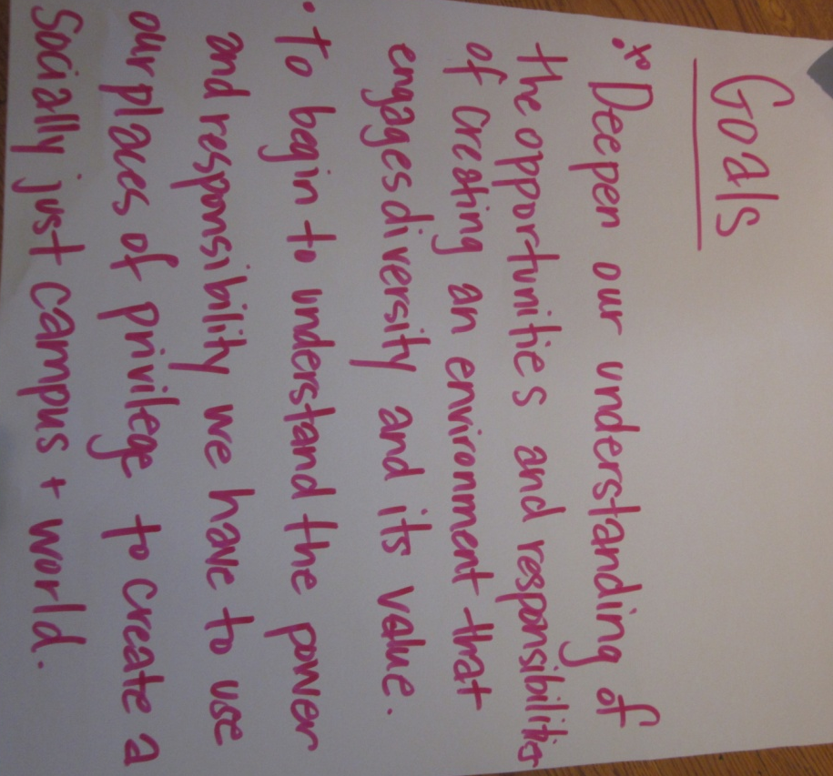

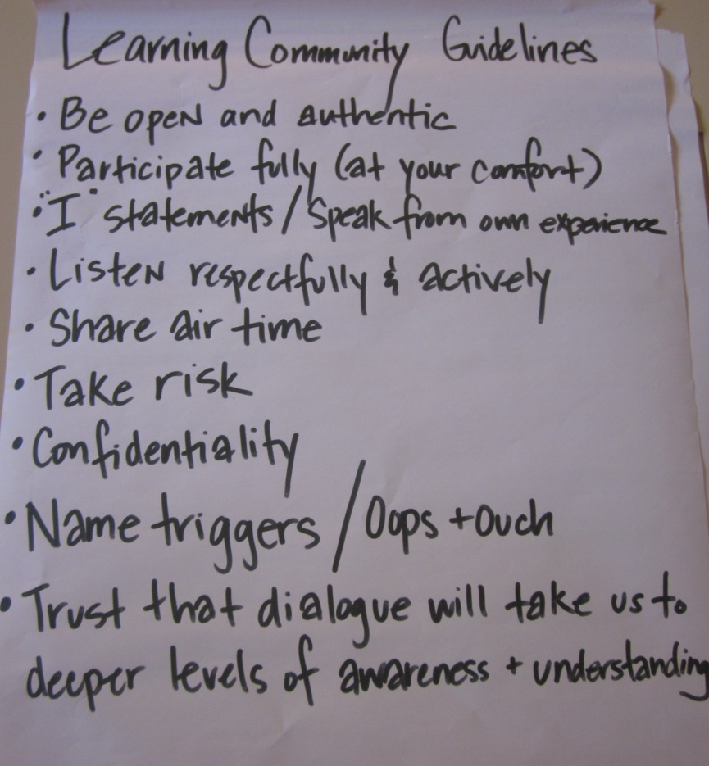

Path to Competence Activity:
After going over our goals and guidelines, Sam explains the next activity, where she talked about a Path To Competence (poster pictured below). This path has different quadrants where people may place their competence level, depending on the subject. She also discussed the judgment line and how we often judge people we perceive as not knowing as much as us about a particular topic and that the 4th quadrant, competence, is not really a place where people live, but a place where you visit. She original used the example of a time share and then caught herself and said that was a pretty classed explanation and said she is constantly working on these various subjects and often going back and forth between quadrants. Sam called out different subjects (social justice, race, class, ability, religion) and asked us to place ourselves in the quadrant we felt we belonged. We would then turn to one or two people near us and discuss why we were there or what we were thinking.
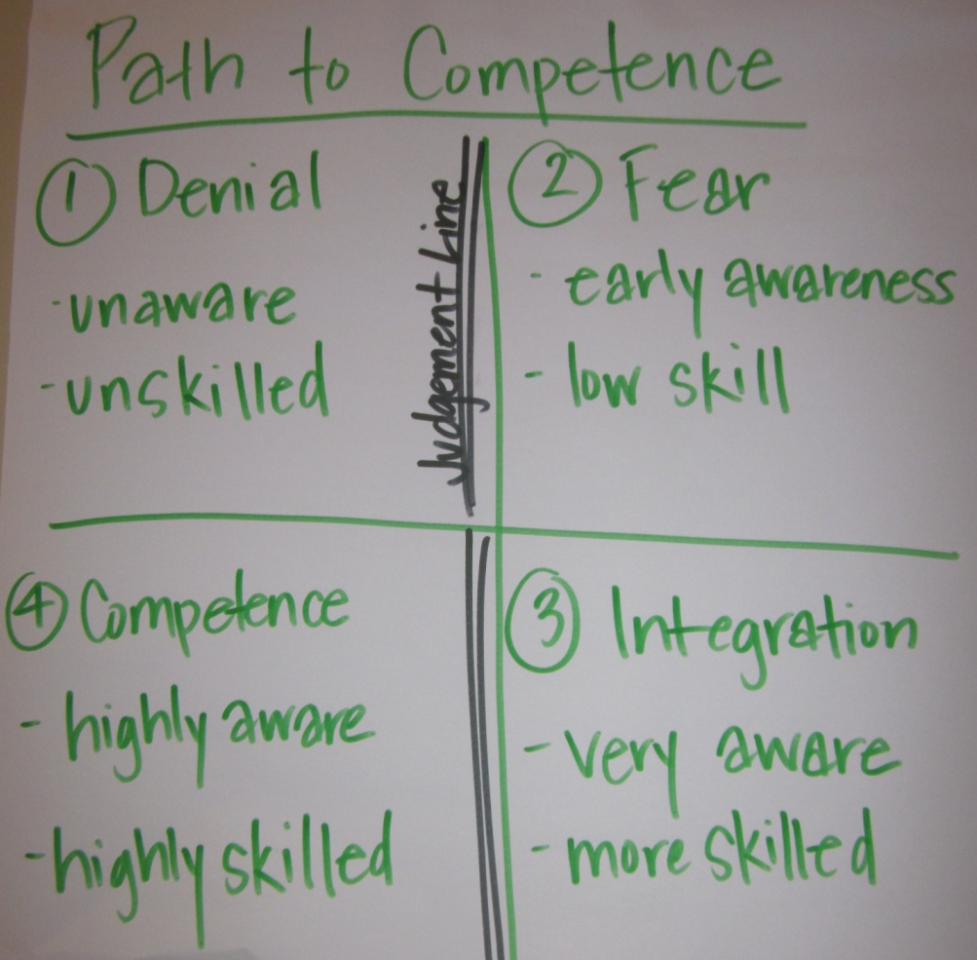

Privilege Bouquet:
After this we moved into the privilege bouquet activity where people walked around the space quietly, reading the signs, and taking the slips of paper that applied to them (a couple pictures below). After everyone completed the activity, we broke into small groups. Heather, Sam, and I each facilitated a group, and I don’t think I mentioned it before but in earlier activities if we weren’t facilitating, we participated, so, everyone had done the privilege bouquet activity. In small groups we talked about the activity and also had a piece of paper with prompting questions about privilege in general. My group talked about the activity for a little; we asked questions about signs we might not have understood (for example, one about the glass ceiling) and talked about how our answers depended on where we were (ie: school or home). We then moved into some of the questioned and one of the common themes we discussed was who has the ownership/who is in the position to confront someone. Some examples were when a person who was white was offended by a Chinese person putting on a fake Chinese accent, she wasn’t sure if she could say anything; because her friend is Chinese, is she allowed to make fun of her own group? We also talked about ownership of certain words, like the “n” word. Another topic was what it means to be an ally, and who gets to name allies. We were still talking when time ran out, and we had to conclude the workshop.
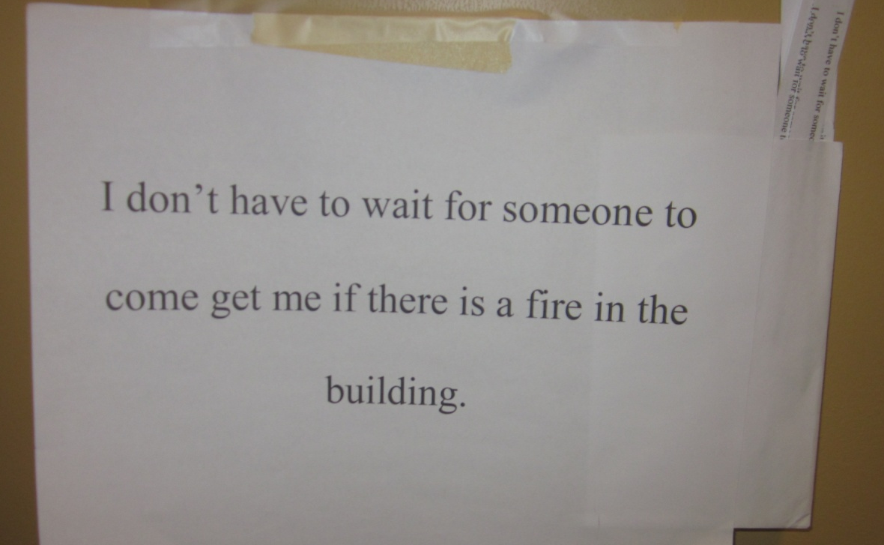
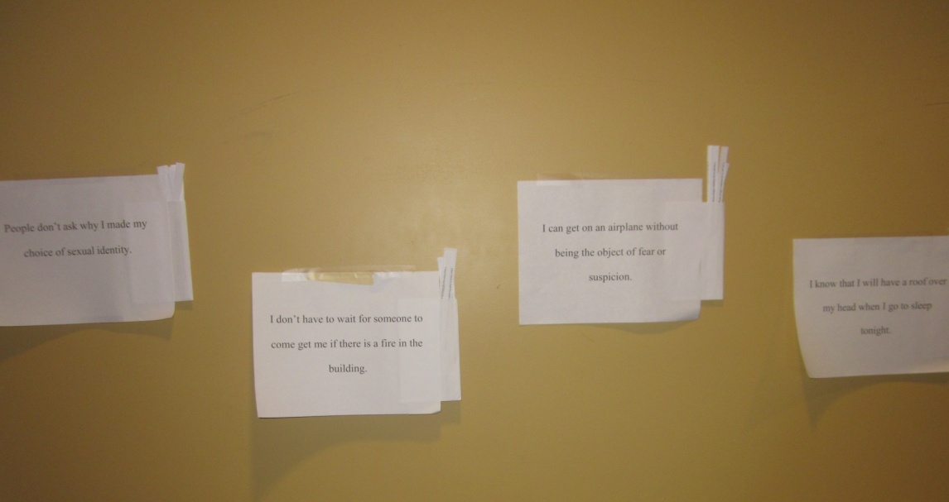

Conclusion:
Gave the full group a chance to bring up anything that was discussed in small groups, assigned “homework”, and mentioned that there would be a informal discussion before the next workshop. Finally, thanked everyone for coming and sharing and learning from one another.

